**DAILY ONLINE ACTIVITIES SUMMARY**

|  |  |  |  |  |  |  |  |  |
| --- | --- | --- | --- | --- | --- | --- | --- | --- |
| **Date:** | **18-05-2020** | | | | | **Name:** | **SHASHIKANT CHAVAN** | |
| **Sem & Sec** | **8th sem B sec** | | | | | **USN:** | **4AL16CS090** | |
| **Online Test Summary** | | | | | | | | |
| **Subject** | | **SMS** | | | | | | |
| **Max. Marks** | | **60** | | **Score** | | | **57** | |
| **Certification Course Summary** | | | | | | | | |
| **Course** | **Python Programming in Hindi** | | | | | | | |
| **Certificate Provider** | | | **Great learning website** | | **Duration** | | | **10-12.30** |
| **Coding Challenges** | | | | | | | | |
| **Problem Statement: java coding problem** | | | | | | | | |
| **Status: completed** | | | | | | | | |
| **Uploaded the report in Github** | | | | | **Yes** | | | |
| **If yes Repository name** | | | | | **Shashikant_chavan** | | | |
| **Uploaded the report in slack** | | | | | **yes** | | | |

Online Test Details: (Attach the snapshot and briefly write the report for the same)

Certification Course Details: (Attach the snapshot and briefly write the report for the same)

Saw videos related to Pyrhon Programming

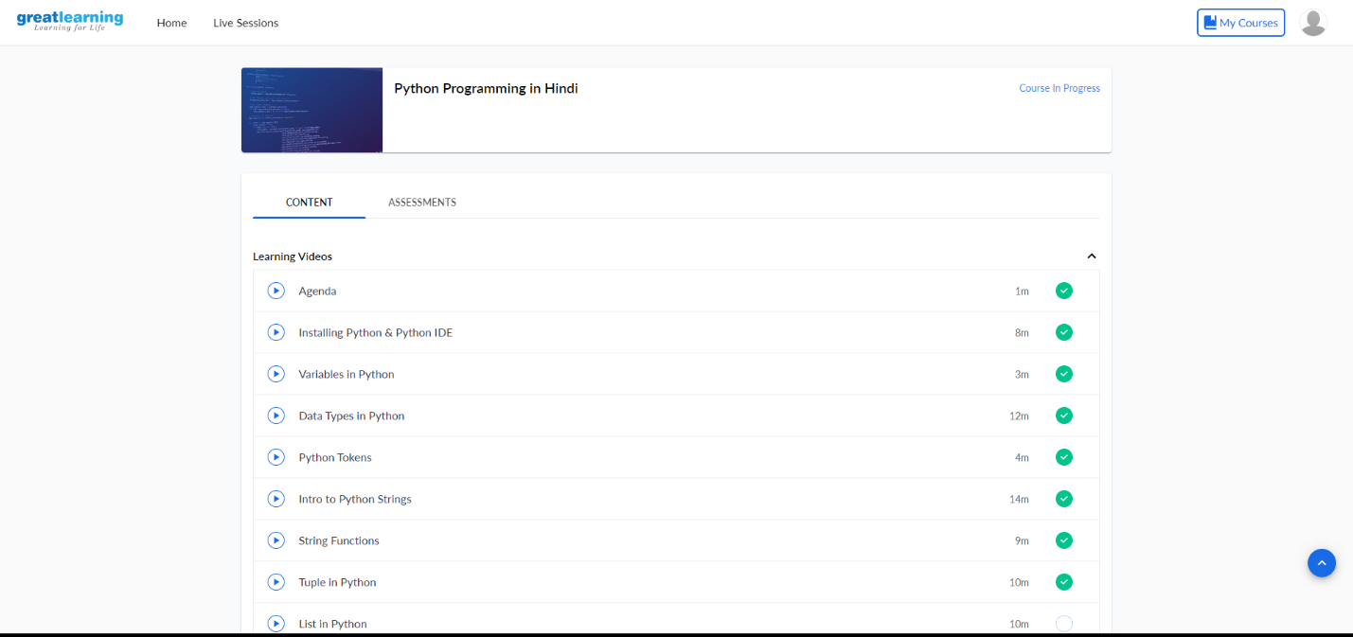

Coding Challenges Details: (Attach the snapshot and briefly write the report for the same)

Coding was given n it was uploaded for github and slack

Program no:1

Write a C Program to Reverse a Linked List in groups of given size.

#include<stdio.h>

#include<stdlib.h>

struct Node

{

int data;

struct Node* next;

};

struct Node reverse(struct Node head,int k)

{

struct Node current= head;

struct Node next= Null;

struct Node prev= Null;

int count = 0;

while(current!=Null && count<k)

{

next= current->next;

current->next = prev;

prev= current;

current= next;

count++;

}

if ( next!=Null)

head->next= reverse( next,k);

return prev;

}

void push( struct Node ==head_ref,int new_data)

{

struct Node= new_node= (struct Node*) malloc(sizeof(struct Node));